**Project Name: Make an E-commerce Website for Sporty Shoes**

**Developer Name:** Kapil Davey

**GitHub Link:** [**https://github.com/kapildavey/Phase-3.git**](https://github.com/kapildavey/Phase-3.git)

**Output:**

**Manage the products in the store including categorizing them:**

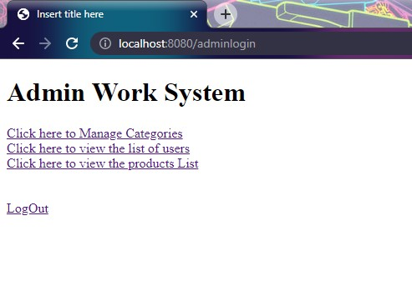

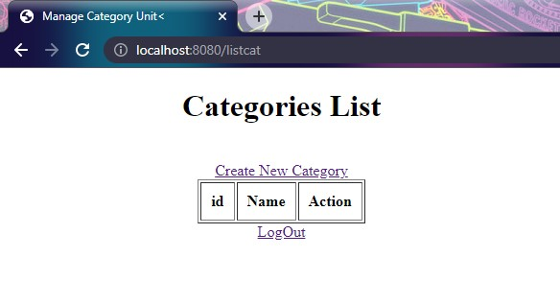

**Browse the list of users who have signed up and be able to search users:**

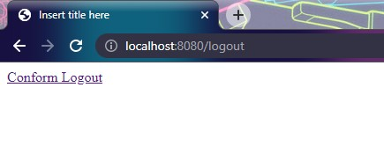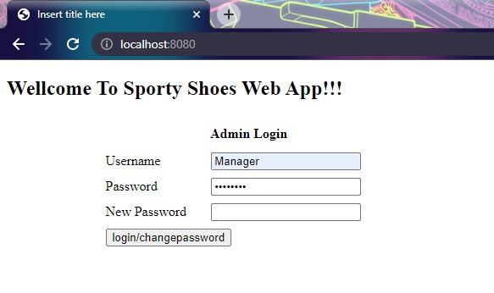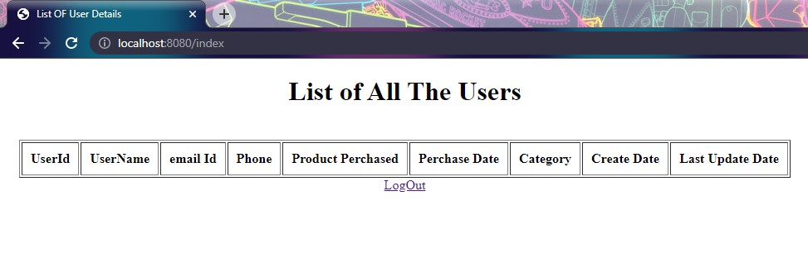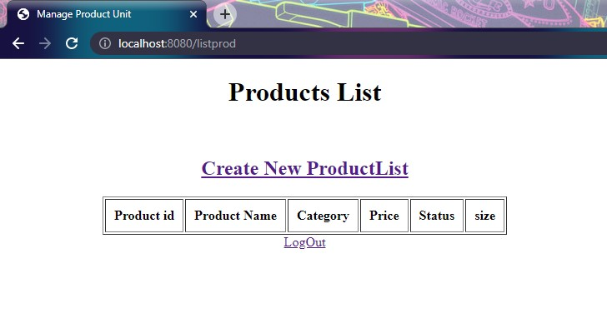**See purchase reports filtered by date and category:**

